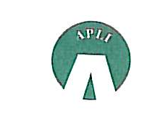

ASSOCIATION OF PENSION LAWYERS IN IRELAND

ANNUAL DINNER

to be held at

Number 25 Fitzwilliam Place
Dublin 2

On
Thursday 11 October 2018

Champagne Reception 7.30 pm
Dinner 8.00 pm

Cost €95
Dress Code: Black Tie

Kindly complete the attached RSVP form
And send the form and your remittance by Friday 5 October 2018 to:

Sarah McCague
c/o Arthur Cox
Ten Earlsfort Terrace
Dublin 2, D02 T280

Email: sarah.mccague@arthurcox.com

